Source https://www.viator.com/tours/Seoul/Nami-Island-and-Petite-France-Include-Lunch-and-Entrance-fee/d973-101420P9
__________________________________________________________

K-Drama Dreamscape Journey: Nami Island, Petite France & Garden of Morning Calm
__________________________________________________________
★★★★★ 4.5/5 20 reviews

Add to wishlist ♡

__________________________________________________________

1 day | €110 per person

🏕  Image | 🏕  Image | 🏕  Image | 🏕  Image | 🏕  Image | 🏕  Image

__________________________________________________________
About This Tour
Step into the cinematic landscapes of South Korea on a full-day private adventure inspired by iconic K-drama filming locations. This immersive journey blends nature, culture, and storytelling as you explore the romantic tree-lined paths of Nami Island, wander through the storybook village of Petite France, and optionally discover the serene beauty of the Garden of Morning Calm. With private transport, a knowledgeable guide, and seamless logistics, this experience is designed for travellers seeking comfort, insight, and unforgettable scenery.
__________________________________________________________
What’s Waiting for You
- Duration: 8–10 hours
- Group Size: Private tour (only your group participates)
- Languages Available: English
- Guide: Fluent English-speaking driver-guide
- Transportation: Private air-conditioned vehicle with hotel pickup & drop-off
- Accessibility: Wheelchair and stroller accessible
- Season: Available year-round
__________________________________________________________

Check Dates & Availability

Select participants: (Age 99 and younger) - 1 +

Choose date:
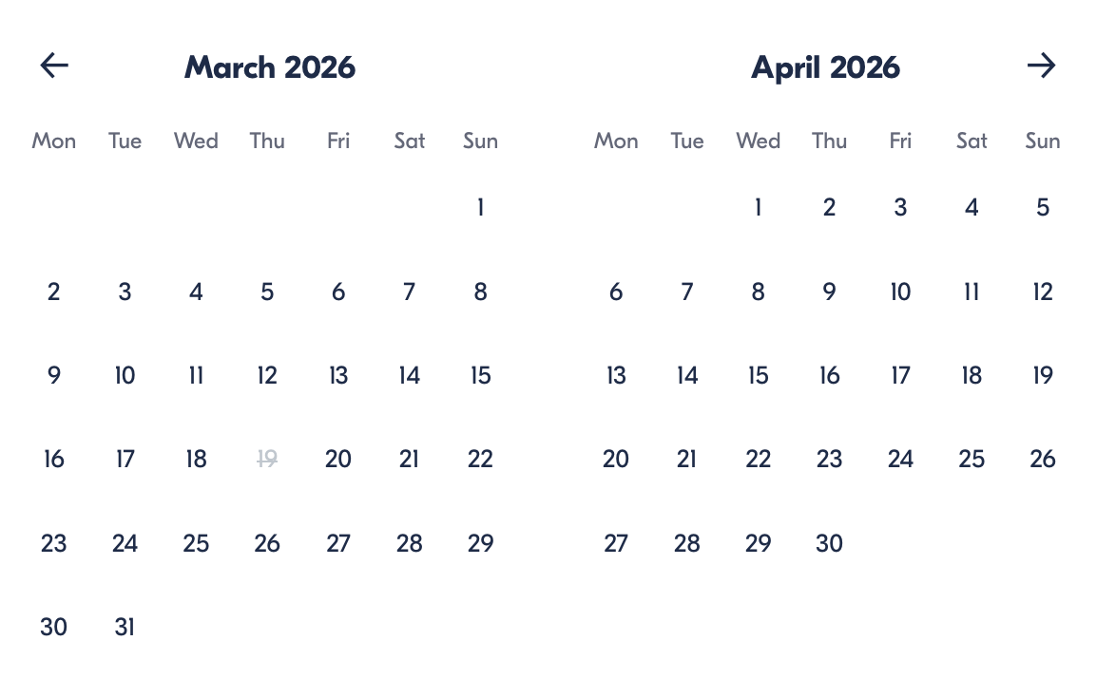

Check Availability

opens:

Participants: 1 March 16, 2026

K-Drama Dreamscape Journey: Nami Island, Petite France & Garden of Morning Calm

- Duration: 1 day
- Offered in: English
- Starts at: 7:30 AM

Cancellation:

- More than 24 hours before start — Full refund
- Less than 24 hours before start — No refund

Price breakdown: 1 Participant x €110

Total: €110

The total price includes all taxes and fees.

Add to cart Book now

__________________________________________________________
Tour Features
- Nami Island Escape: Walk beneath iconic tree avenues made famous by Korean dramas.
- Petite France Village: Explore a whimsical European-style cultural park in the Korean countryside.
- Optional Garden Visit: Enhance your day with a visit to one of Korea’s most beautiful botanical gardens.
- Private Transfers: Door-to-door hotel pickup and drop-off in Seoul.
- Personalised Experience: Private format ensures flexibility and deeper interaction with your guide
__________________________________________________________

Scenic Cultural Adventure
Your day begins with a convenient pickup from your Seoul hotel, Airbnb, or accommodation. Travel comfortably through the countryside toward Nami Island, a beloved destination located about 63 km from Seoul. Known for its peaceful landscapes and romantic atmosphere, the island features picturesque tree-lined paths, open green spaces, and leisure areas, including water activities and themed attractions.
Next, visit Petite France, a charming theme park inspired by traditional French villages. Its pastel-colored architecture, exhibitions, and cultural displays create a whimsical atmosphere that feels like stepping into a European fairytale — a favorite filming location for many Korean dramas.
For guests choosing the extended option, continue to the Garden of Morning Calm, one of Korea’s oldest private gardens. With more than 5,000 plant species and seasonal festivals year-round, this tranquil botanical haven offers a beautiful contrast to the lively theme park and island scenery.
After a full day of exploration, relax on the return drive back to Seoul, where you’ll be dropped off at your preferred location.
__________________________________________________________
Included in Price
- Lunch
- Private transportation in an air-conditioned vehicle
- English-speaking driver-guide
- All taxes and fees
- Entrance fees
__________________________________________________________
Not Included
- Personal expenses
__________________________________________________________
Who Should Avoid This Tour
- Travellers unable to spend extended hours touring (8–10 hours total duration)
__________________________________________________________
Important Trip Info
- Confirmation is provided at booking.
- Tour is fully private — only your group participates.
- Service animals are allowed.
- Accessible transportation and surfaces are available.
- Most travellers can comfortably join.
- Pickup and drop-off available from hotels, motels, and Airbnb accommodations within Seoul.
__________________________________________________________

Cancellation Policy
For All Participants:

- More than 24 hours before start — Full refund
- 24 hours or less before start — No refund
__________________________________________________________
What Our Clients Are Saying

Overall rating  4.5/5  ★★★★★  Based on 20 reviews | Review summary  Guide 4.5/5  Transportation 4.6/5  Service 4.7/5  Organisation 4.5/5

Filter  - All traveller types  - Couples  - Group of friends  - Families  By star rating  - All star ratings  - 5 stars  - 4 stars  - 3 stars  - 2 stars  - 1 star | Search reviews (e.g., guide)  Sort by:  - Top picks  - Latest reviews  - Best ratings  - Lowest ratings
__________________________________________________________
★★★★★
Daniel M. — United States
This private tour felt like stepping into a movie set. Nami Island was stunning, and our guide’s stories made the experience even more meaningful.
★★★★★
Min-jun K. — South Korea
Beautiful scenery, smooth organisation, and a fantastic guide. Petite France was charming and unique.
★★★★★
Liang Z. — China
Everything was perfectly arranged. The landscapes were breathtaking, and the day was relaxing yet full of discoveries.
★★★★★
Claire R. — France
Such a magical day trip from Seoul. The garden option was peaceful and absolutely worth it.
★★★★★
Takumi S. — Japan
A wonderful mix of culture, nature, and sightseeing. Highly recommended for visitors wanting something special outside the city.
See more reviews
__________________________________________________________

Meta tags

Page - K-Drama Dreamscape Journey: Nami Island, Petite France & Garden of Morning Calm

Title: K-Drama Dreamscape Journey: Nami Island, Petite France & Garden of Morning Calm | Travellio Global

Description: Discover Korea’s most picturesque destinations on a private day tour from Seoul. Visit Nami Island, Petite France, and the Garden of Morning Calm with a guide, transport, and lunch included.

H1 - K-Drama Dreamscape Journey: Nami Island, Petite France & Garden of Morning Calm
__________________________________________________________

